**MySQL Runtime Mac**

1. Open a Terminal window
2. In the Terminal window type **cd /usr/local/mysql/bin**
3. In the Terminal window type **./mysql -u root -p**
4. In the Terminal window at the password prompt type the configured password. When typing the password, the cursor doesn’t move.

1. Type “help”

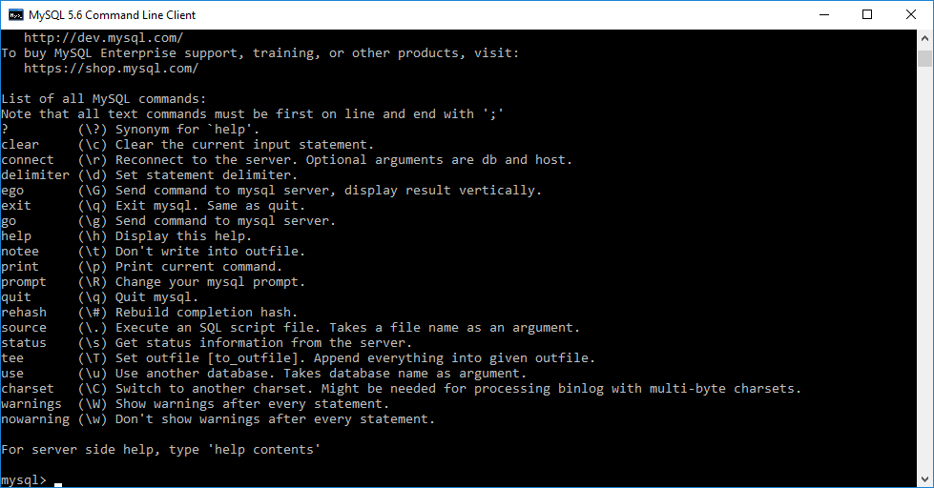

1. Type “show databases;”

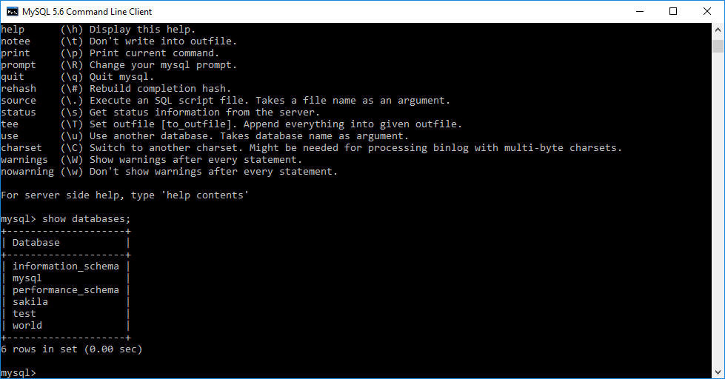

1. Type “use world”

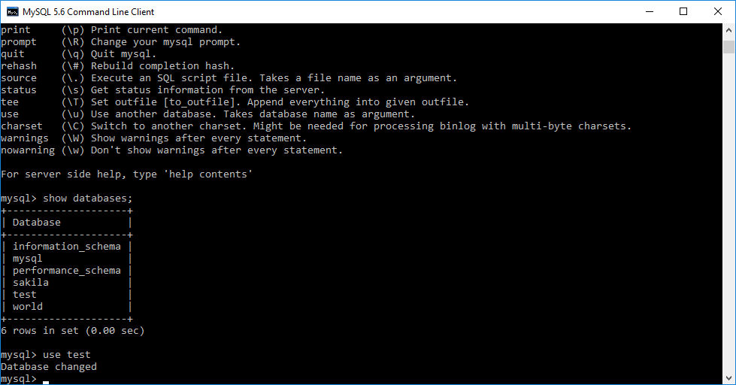

1. Type “show tables”

